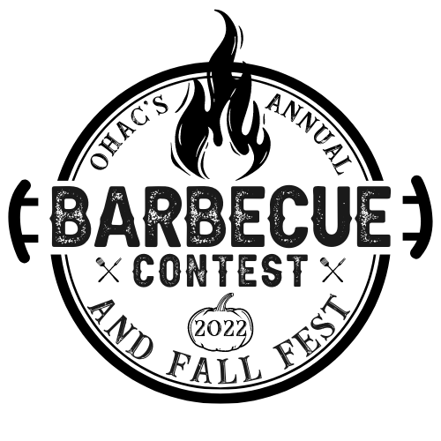

HOW TO ENTER
- Registration fee per team is $25. Cash, Check, or Credit Card accepted.
- Submit online at ohacenter.org or orchardhillschurch.org/events
Or mail completed registration form with payment to:
Orchard Hills Achievement Center
6032 Cloverdale Road
Roanoke, VA 24019
Atten: Lisa Miles
- Each team will be assigned a 10X15’ area. You provide your own tables and equipment.

OHAC Barbeque Competition RULES AND REGULATIONS

- CONTESTANT - A contestant is any individual or group that will prepare and cook an entry or entries for the purpose of being judged. Contestant and all team members must be amateur competitors. The contest organizer may not cook in any category in this contest. Contestant will be referred to as “Griller.”

- INTERPRETATION of RULES - The interpretation of the rules and regulations are those of the contest organizer and his or her decisions are final.

- REFUND OF ENTRY FEES – There will be no refund of entry fees unless approved by the organizing committee.

- EQUIPMENT – Each Griller will supply all of the equipment necessary for the preparation and cooking of their entry including a cooker. COOKER can ONLY be one of the following: Gas, charcoal, electric, or wood (NO open/pit fires). The health and safety of contestants and event goers should be a primary consideration when selecting appropriate cooking fuels.

- MEAT INSPECTION – All meats must be USDA or state DA inspected and passed. All meat must be maintained at a maximum temperature of 40 degrees F prior to inspection. Prior to cooking, all meat that is resting in preparation for cooking must be covered at all times. All contest meat, once inspected, may not leave the Griller’s site until turned in for judging. After check-in inspection, the meat may be marinated, salted, seasoned, or cooked by the Griller. All meats must be cooked to a minimum internal temperature of 145 degrees F. After cooking, all meat must be maintained at a minimum temperature of 140 degrees F in a covered container until turned in for judging.

- CONTESTANT’S SITE – Each Griller is required to keep all equipment including cooker, canopy, etc. contained within assigned space.

- CLEANLINESS AND SANITATION – All Grillers are expected to maintain their cook sites in an orderly and clean manner and to use good sanitary practices during the preparation, cooking and judging process. The use of sanitary gloves is required at all times while handling food. Failure to use sanitary gloves may result in disqualification. Grillers are responsible for cleanup of their site once the competition has ended. All food safety rules and regulations must be adhered to at all times. A sanitation/water supply will be provided for all teams use during this event.

- MEAT CATEGORIES – The following categories are included in competition:
  - Boston Butt – weighing a minimum of 10 lbs. or more must be cooked as a single piece of meat. A 10 lbs. donation of pulled pork to be sold as a fundraiser for OHAC is required of all contestants.
  - Pork Ribs – minimum of four (4) ribs
  - Smoker’s Choice – any meat of your choosing

BONUS POINT CHALLENGE! Grillers are invited to participate in an After-Smoke Challenge. Each participant has the option to enter a side or dessert from their grill after all meat items have been turned in to be judged. The Griller who wins the challenge round will be awarded one (1) bonus point toward their overall score for the competition.

- JUDGING – Entries will be submitted in the containers supplied by event organizer at check-in by the Griller. Each entry will be judged on APPEARANCE, TASTE/FLAVOR, TENDERNESS and TEXTURE. Meat may be sauced or un-sauced. A minimum of four (4) separate and identifiable portions per category in containers supplied to Griller at check-in must be submitted for judging.

- SCORING – Each entry will be scored by four (4) judges in the areas of
APPEARANCE, TASTE/FLAVOR, TENDERNESS and TEXTURE. Scoring from each judge ranges from a low of 1 to a high of 10 in increments of 1 point for each category, for a total of up to 40 points from each judge. Any entry that is disqualified as per SECTION 11 will receive a score of zero for all four categories from all judges at the table.

- DISQUALIFICATION – An entry can be disqualified by the event organizer only. An entry can be disqualified for any of the following reasons:
- There is anything foreign other than meat/sauce in container submitted for judging.
- The entry is turned in after the officially designated time.
- Gloves are not used while handling food products.
- Not cooking the meat that was inspected.
- There is not a minimum of four (4) separate and identifiable containers for each category entered.
- There is evidence of blood such that the meat is uncooked.

12. TURN-IN TIMES – per competition item as follows:
- Boston Butt – 11:45 AM to 12:00 PM EST
- Pork Ribs – 12:45 to 1:00 PM EST
- Smoker’s Choice – 1:45 to 2:00 PM EST
- Bonus Challenge- 2:45 to 3:00 PM

- JUDGING PROCEDURE – The event organizer brings all approved containers to the table. He/She announces the number of containers to be judged, opens each container and checks for rule violations as stated above. The containers will be passed around to the judges for sampling. The judge will then score each entry for APPEARANCE, TASTE/FLAVOR/TENDERNESS and TEXTURE. The event organizer makes sure that all scores for the containers are recorded in the proper place. This procedure is repeated for all containers. After each container has been scored the event organizer will return the container(s) to the designated area. The event organizer will then collect the judging slips.

- WINNERS – Grillers in each of the four (4) categories will have the opportunity to win First (1st), Second (2nd), or Third (3rd) Place. The winners in each category will be determined by adding all the scores together for the following divisions – (A) BOSTON BUTT, (B) PORK RIBS (C) SMOKER’S CHOICE, (D) AFTER SMOKE CHALLENGE. THE GRAND CHAMPION Title will be the Griller with the most total points and be declared the 1st Place Trophy Winner. THE RESERVE GRAND Title will be the Griller with the next highest total points and will be declared the 2nd Place Trophy Winner. In the event of a tie, the next lowest rank will be omitted and the tied Grillers will be awarded the same rank. Winners will be announced at 3:30pm from the judge’s stage.

- GRILLERS may not sell any food items.

Questions? Call Lisa Miles (540)206-4954

